Name Date Class

Chapter 2 Project

Draw a diagram that shows the process that a rock would go through to change from a mountain into a piece of marble or slate. You will need to include all of the parts of the process. Below your diagram, you will need to include a key that explains what each step in the process does to the minerals and rocks as they move through the cycle. You may use these images to help you.

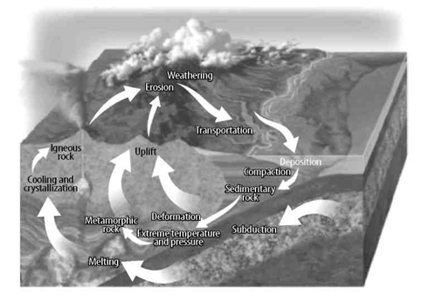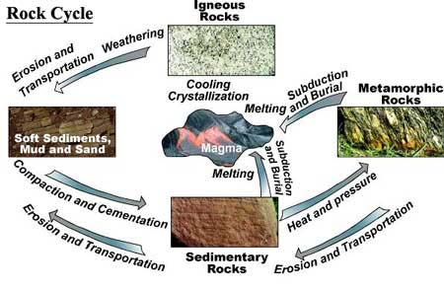

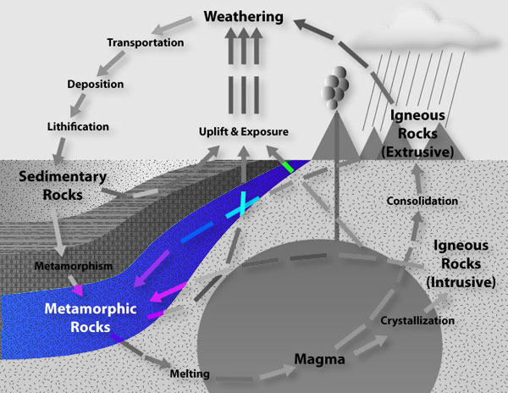

Your project must be neat, carefully designed and decorated, and all information has to be accurate. We will use the rubric to evaluate your work. You will be asked to self-evaluate before you turn in the project.

Project Steps:

- Choose a metamorphic rock type: marble or slate.
- Review the textbook to determine what type of rock it originally was: sedimentary or igneous.
- Review your notes and the textbook to see how that type of rock forms.
  - Step 1
  - Step 2
  - Step 3
  - Step 4
  - Step 5
- Review your notes and textbook to see how that type of rock changes into a metamorphic rock.
- Step 6
- Step 7
- Step 8
- Step 9
- Step 10
- Design your illustration. Use pencil, so you can correct any errors or make any changes.
- Add a key to the bottom of the page to explain each step in the process that you have identified.
- Color and/or finalize your project with ink. I do not suggest using markers as they run and smear. You could use colored pencils as well.
- Be sure to include your name, the date, and your class on all pieces and parts of the project.
- Evaluate your work using the rubric.

Project Rubric

 | 1 | 2 | 3 | 4 | 5
Neatness | Messy and hard to read | Some errors and messiness | Appropriately neat | Neat and carefully created | Extra effort evident
Follows directions | Items missing or incomplete | Some items missing or incomplete | Most items are included and complete | All items are included and complete | Extra effort evident
Completed on time | Two or more days late |  | One day late |  | On time
Accuracy of information | Inaccurate information, incomplete information, details not in correct order | Missing a number of the steps in the rock cycle or steps are in the wrong order or hard to follow | Most steps in the process are included, explained, and in the correct order | Work shows effort and is complete and fully explained and in the correct order | Exemplary work with all parts of the process included and fully explained
Heading information on all pieces | NO |  |  |  | YES

Name Date Class

Type of Rock: _____________________

Project Key:

