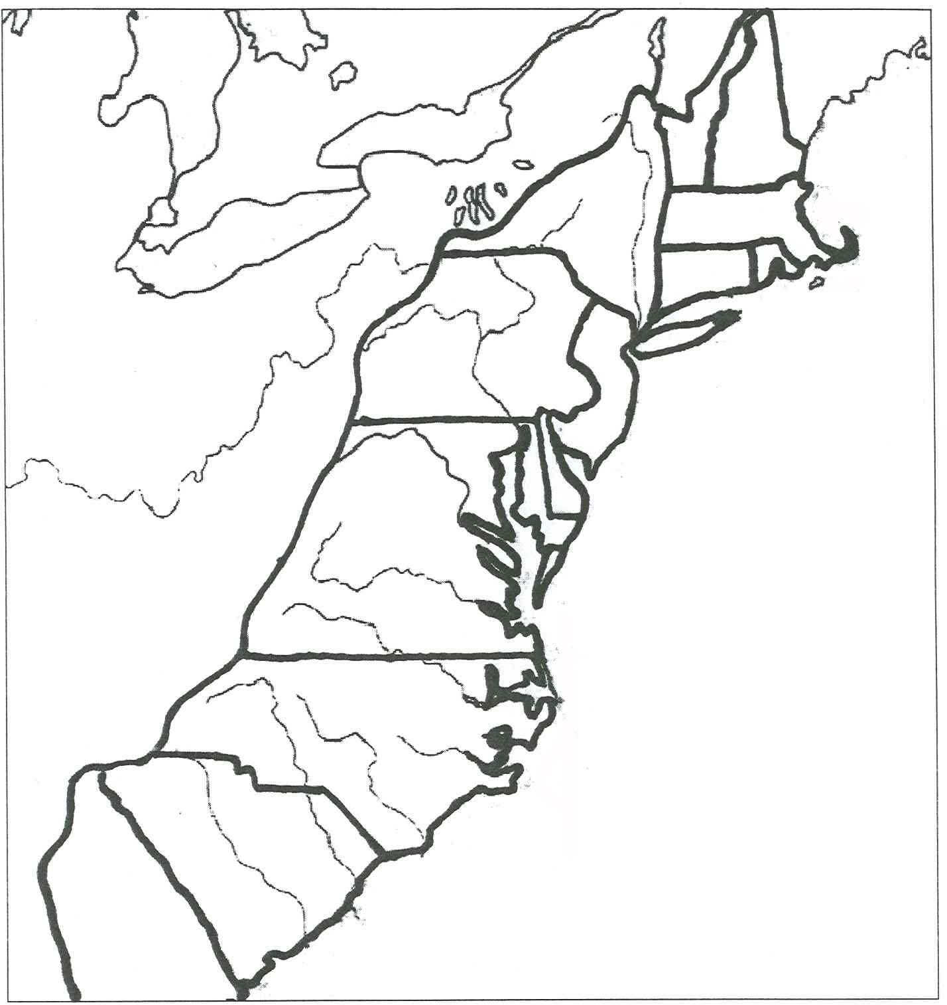

- Neatly label each of the colonies on this map.
- Label the location of Roanoke, Jamestown, and Plymouth Colony.
- Draw one picture to represent something of importance about each colony.
- Write one fact about each colony.

